DSM2 Sediment Transport Module Design Plan
by Prof. Fabián A. Bombardelli
Program Manager: Dr. Jamie Anderson

(Version of Wednesday, April 15, 2009, which serves for the meeting at CA DWR on the same day and subsequent meetings)

Goal statement

The aim of the present project is to:

1) Incorporate the capability of simulating sediment transport and bed-level change to DSM2;
2) validate the resulting sub-models first with measurements obtained from the literature, and second with observations of sediment concentrations in the Delta;
3) include a link to the water-quality sub-module (QUAL) in DSM2 to simulate in the future the transport of pollutants attached to particles; and
4) organize an inventory with datasets about flow and sediment transport in the Delta.

The project will involve the development of adequate theoretical sub-models which will be implemented numerically in sub-routines. These sub-routines will take part in a new module of DSM2 (whose name will be determined through a competition in DWR) which will allow for addressing the sediment transport as bed-load and in suspension, the change in bed elevation due to natural events and/or man-made activities, and which will also link the module of water quality (QUAL) with the sediment-transport module in order to simulate cases of pollutants that attach significantly to particles (like mercury and other heavy metals). DSM2 will be then used to simulate historical and future conditions of flow and sediment transport in the Delta.

Key sediment transport processes

The sediment processes to be considered in the model are (see Fig. 1):

a) transport of sediment in suspension, away from the bed, including advection due to currents and dispersion of sediment;
b) transport of sediment as bed-load, close to the bed, including all motions accounted for through empirical formulas;
c) erosion and deposition of sediment;
d) agglomeration and break-up of sediment particles;
e) change in bed elevation due to the net effect of erosion and deposition of sediment.

The new sub-routines will include the transport of non-cohesive as well as cohesive sediment. The cohesive nature of the sediment will be accounted for by expressions which depend on the sediment concentration and/or other convenient properties.

Initially, a unique sediment size will be considered, but then a series of sediment-size classes will be taken into account (about 20 or 30).

Sediment transport equations

The equations for the transport of sediment in suspension are as follows:

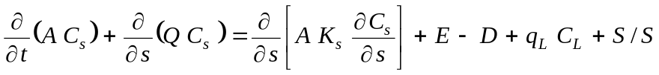 (1)

where  is the cross-sectional wetted area (m²); 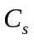 is the volumetric cross-sectional-averaged concentration of sediment in suspension (-);  is the discharge (m³/s); 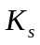 denotes the dispersion coefficient (m²/s);  indicates the entrainment rate of sediment into suspension per unit width (m²/s);  represents the deposition rate of sediment per unit width (m²/s); and 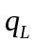 (m²/s) and 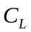 (-) refer to the lateral discharge (per unit width) and the volumetric concentration of sediment in the lateral discharge. In turn, and indicate the spatial and time coordinates, respectively, and 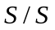 denotes sources and sinks of sediment of non-point nature. In the case of having several size classes, this equation will be solved for each class including in the terms the processes of agglomeration and break-up of sediment particles.

The transport of sediment as bed-load will be computed via empirical relations taken from previous studies. Such relations can be recast as special cases of the following relation:

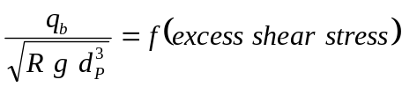 (2)

where 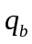 is the solid discharge due to bed-load per unit width,  is the submerged specific gravity, given by 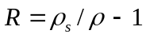, with 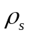 and  denoting the densities of sediment and water, respectively; is the acceleration of gravity; and 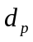 is the particle diameter. These relations are said to pertain to “capacity” conditions, whereby the river can scour sediment according to the load it can actually carry. Again, this equation can be posed for each particle size class. One such relation, albeit for the total bed-load transport, has been developed for the Delta by the United States Geological Survey (USGS) through the consideration of the motion of dunes, as follows: 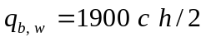, where the solid discharge is expressed in weight per unit time; is the celerity of the bedform; and is the height of the bedform (see http://ca.water.usgs.gov/program/sfbay/calfedsed/bedsurveys/equation.html).

The conservation of mass for the sediment in the bed, namely, the Exner equation is:

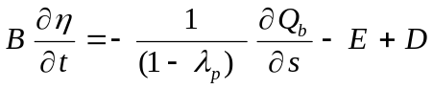 (3)

where 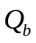 is the total bedload solid discharge; 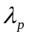 indicates the average porosity of the bed material;  is the width of the channel; and is the bed elevation above a certain datum. (The adequate definition of for the cross sections of the Delta will be analyzed in detail.) For any specific size class, Eq. (3) needs to be modified to account for the fraction of the class in the overall size distribution of the material.

Entrainment formulas for non-cohesive and cohesive sediment are usually expressed in terms of the wall-friction velocity (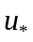) or the shear stress. For instance, the formula by García and Parker reads:

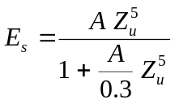 (4)

where is a constant equal to 1.3 x 10⁻⁷; 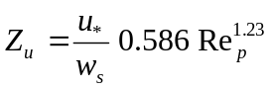, with 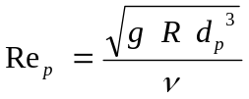(the explicit particle Reynolds number); 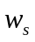 indicates the fall velocity; and denotes the kinematic viscosity of water. Once 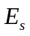 (which is a non-dimensional number) is computed, it follows that: 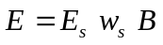. In turn, 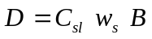, where 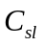 is the local sediment concentration at a distance from the bed. (This concentration can be related to the cross-sectional concentration of sediment through empirical coefficients.) The García and Parker formulation is one of the few which include a version for several classes of sediment size.

Numerous expressions have been presented in order to facilitate the computations of the fall velocity, . In this project, the regression proposed by Dietrich (1982) for natural particles will be used.

Discretization and numerical schemes

In a previous meeting, it was agreed that the numerical discretization of the equations will be undertaken outside the QUAL module of DSM2, i.e., an Eulerian approach will be followed for the analysis. This approach will be beneficial if the sub-routines developed herein are to be used as a support of the REALM project.

The selected numerical approximation is based on a centered scheme for the dispersive term, which is evaluated with a weight in times and 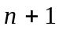, as follows:

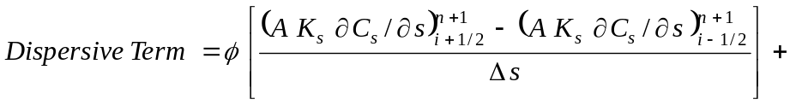
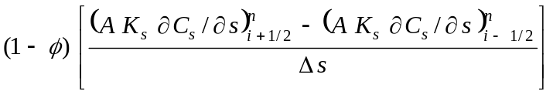 (5)

Discretization of the variables at 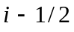 and 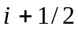 are given on page 332 of the book by Cunge et al. (1980). (The subscript indicates space location while the superscript refers to time.)

The terms including sources and sinks could be treated explicitly. For the advective term, a higher-order upwinding, i.e., a QUICK scheme will be applied.

The Exner equation will be discretized as follows:

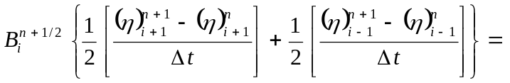

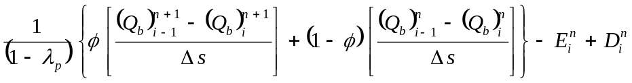 (6)

DSM2 sediment transport module components

The new module of DSM2 will consist of the following sub-modules:

1) Sub-module for the computation of the settling velocity. Here the input is the particle size (sizes), and the implementation can be accomplished through a function within the code. The output is the set of values of the settling velocity, which allow for the computation of the term presented above.
2) Sub-module for the computation of the entrainment rates of sediment into suspension. This can also be implemented in a function within the code. The basic input to this sub-module is the set of cross-sectional averaged velocities, which need to be related to shear velocities which appear in the expressions for entrainment of sediment into suspension. The output of this is the term presented above.
3) Sub-module for the computation of the concentrations of sediment in suspension. This consists in solving the advection-dispersion equation detailed above. The inputs for the sub-routine are the cross-sectional averaged velocities and the areas at each node.
4) Sub-module for the computation of the bed-load transport. The inputs for this sub-module are the velocities at each node and the shear velocities.
5) Sub-module for the computation of the change in bathymetry. Inputs needed: velocities at each node and areas.

Implementation phases

The first stage of the project is to focus on a single sediment size class, and to implement the above sub-modules for such case, excluding the change in bathymetry. With this configuration, the sub-modules will be validated through comparisons with laboratory data.

In a second stage, the condition of single sediment size will be kept, but the change in bathymetry will be added. This will be also validated with laboratory experiments.

In a third stage, several sediment classes will be considered.

Miscellaneous

This is a plan which will be optimized in the near future. I would like to have the most current version of DSM2 (the source code) to understand more about the diverse aspects of the numerical scheme and the structure of the code. I would also like to have some recent and old reports produced by DWR on DSM2.

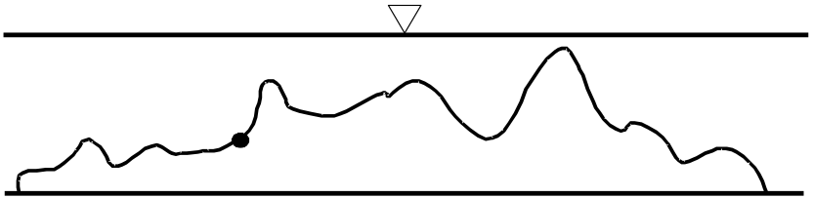

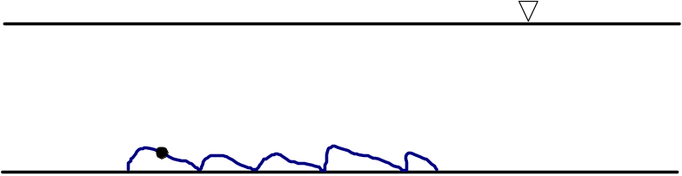

Figure 1: Schematic indicating the different modes of transport of sediment in open channels (taken from Parker, 2004). (a) Transport as bedload. (b) Transport in suspension.

